**DISTRIBUTED IOT ENVIRONMENTAL MONITORING**

**by:**

**Mr F.J. Fourie**

**26047799**

**Project Proposal**

Submitted in pursuit of the degree

**BACHELOR OF ENGINEERING**

**In**

**COMPUTER AND ELECTRONIC ENGINEERING**

**North-West -University Potchefstroom Campus**

Supervisor: Prof A. Helberg and Dr M Ferreira

Potchefstroom

2018

# Cover letter

19 February 2018  
Prof. A Helberg, Dr. M Ferrer   
Department of Electrical- and electronic engineering   
NWU  
Potchefstroom, North West Province, 2531

Project Proposal

Dear Prof A. Helberg and Dr. M Ferreira,

I am writing in regard to the final year project proposal for the distributed IOT environmental monitoring project. In the following document my project proposal is defined in terms of the problem statement, scope, work breakdown structure, schedule and budget of the project. I am confident that from this document a clear depiction of my approach to the project can be attained, though this approach I hope to successfully conduct this final year project.

In this document I describe the problem as I understand it and what approach I am planning on taking to solve the problem. I have included my high level solution idea as well as the benefits of this project and why I think it is a feasible solution. I have also clearly shown what I think is within scope for this project and what I think is outside scope for this project it is clearly shown in my WBS.

I am confident with hard work and diligence I will successfully and satisfactory complete this project. I look forward to working on this project.

Sincerely,

FJ Fourie

26047799

30 Esselen Street

Potchefstroom, North West Province, 2531

071 372 1097

Fjfourie29@gmail.com

Table of Contents

1. Cover letter 2

2. Summary 4

3. Problem statement and motivation 4

4. Scope definition 5

5. Anticipated benefits or Project objectives 7

6. Project Plan 8

7. Conclusion 9

Table of figures

Figure 1: Work breakdown structure 6

Table of tables

Table 1: High level Schedule 8

Table 2: High level Budget 9

# Summary

During this project a significant aspects of the problem is that there is no reliable way to determine and know the coefficient of performance (COP) of a split type air-conditioning unit. This has the consequence that air conditioning units are left to operate even after they have become much less efficient than they are supposed to be and vice versa meaning air conditioning units are replaced before it is truly necessary. This results in a loss of energy and capital for the company, through the implementation of a system there can also be some minor bonuses such as predictive maintenance. In this project the problem will be solved by making use of IOT sensors that will be fitted to existing installed split unit air conditioners. These sensors will be able to send data over the internet so that the COP of any air conditioning unit can be calculated at any time also the data will be used to enable the prediction of when a unit needs to be repaired or serviced.

# Problem statement and motivation

There exists a major problem in the management of split unit air conditioners in commercial properties in the sense that it is extremely hard to know when an individual unit needs replacement or maintenance. Additionally, the discomfort a client can experience if his air conditioning unit is to brake and then he has to work or have meetings in a non-air-conditioned office. These two problems lead to energy and capital being lost and wasted. Especially currently in our country with rising electricity prices and energy shortages it is important to conserve energy where possible. The wrongful replacement (too early or late) of air conditioning units leads to a loss in capital in either one of two ways namely a higher electricity bill because of inefficient units or the costs of replacing a unit before it being necessary.

This leads to the need for an inexpensive solution in the form of standalone units that can be deployed in already existing and operational commercial buildings. These units need to be able to transmit information over the internet to a central unit where the data can be meaningfully interpreted. To solve the problem these units, need to be able to calculate the coefficient of performance of the air-conditioning units at any time in order to determine when a unit needs to be replaced. To improve the general comfort of people working on the commercial property the solution should also be able to predict when a unit needs to be serviced in order to fix units before they brake as to avoid people having to work in non-air conditioned offices where it can be avoided. This entails that the solution needs to consist of multiple sensors as well as a method with which it can connect to the internet to transfer data and it should be connected to IOT to enable the processing of the data. There needs to be an interface that is easy to use and shows all the necessary data to the operator and enables him to easily see the COP of any unit as well as see if there are any units about to break or that needs replacement.

# Scope definition

The scope of this project is to design a standalone unit that is small and non-invasive. The unit needs to have some sensors to be able to determine when the air conditioning unit is on and how effective it’s working by measuring things such as the temperature in the room as well as the temperature of the air the air conditioner is blowing out. The units need to have internet capabilities in order to transmit data, the internet capabilities can be either thru an existing wired LAN (Local Area Network) or an existing WLAN (Wireless Local Area Network) or by making use of Lora. There needs to be a central unit that gathers all the data from the individual units that can interpret the data by means of algorithms and then give meaningful information out. There needs to be an interface created for displaying and interaction with the information.

The objectives of the project are to make use of the above mentioned units that will be created to determine when an air conditioning unit needs to be replaced. This must be determined by making use of the coefficient of performance of the unit that will be calculated by the central unit using the data from the individual units. It should also be able to predict when a unit is going to break or when a unit needs servicing by making use of the information.

The approach that will be used in solving the problem is:

* Identifying, analysing and understanding the problem
* Exploring and researching possible solutions to the problem
* Identify a solution to the problem then specify and describe the solution
* Design the system that will be used and then create a detailed design of it
* Build the system
* Test the system
* Improve the system and finalize it

For this project the creation of the IOT sensor units and the back end program is within scope but the gateway and cloud is outside scope. That means the units and their transmission of data is within scope but the network it is transmitted over is outside scope and then again the receiving and interpretation of the data is within scope.

In the following figure 1 I show the work breakdown structure for the Distributed IOT environmental monitoring project. The figure shows what is within scope for this project and what is outside scope also shows some of the levels of the project.

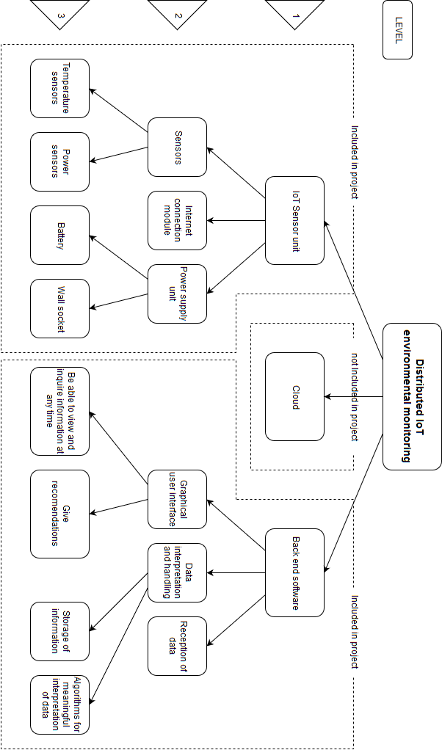

Figure 1: Work breakdown structure

# Anticipated benefits or Project objectives

All the necessary individual components such as sensors and communication mediums needed for this project already exist and they are not too expensive meaning that units will be low cost to build and implement. The low cost in combination with already existing technology availability and the amount of capital the project can save makes it technologically feasible. This project is designed in order that it can be implemented in a wide variety of buildings with a wide variety of infrastructure making it an ideal thing for mass manufacturing and implementation making it financially feasible. The project won’t be invasive and because the project will help conserve electricity it is socially applauded and supported thus making the project socially feasible.

The benefits and objectives of this project is to:

* Save capital by stopping the unnecessary replacement of air conditioning units
* Save electricity by identifying faulty and inefficient air conditioning units
* Increase office comfort by enabling predictive maintenance thus stopping people from having broken air conditioners in their office’s due to unprepared for breakdown

The project will stop the unnecessary wasting of capital that occur during the unnecessary replacement of air-conditioning units. This will be done by monitoring and calculating the coefficient of performance of every air conditioning unit, this will allow the system to tell you the appropriate time is to replace the unit.

The project will also save electricity by informing the operator when an air conditioning unit is no longer working efficiently and needs to be serviced or replaced. This will be done by measuring and keeping track of the performance of all the units as to enable the identification of a unit that shows abnormal behaviour.

Increased office comfort will be a by-product of this project but should not be overlooked, as a comfortable work space facilitates higher productivity and happier employees. This will be done by the identification of air conditioning units showing abnormal behaviour as stated above and then by servicing or replacing them you will stop them from actually braking down and leaving an employee to work in a non-air-conditioned office.

# Project Plan

* 1. Schedule

In below Table 1 the high level schedule is shown which may be subject to change and any change in schedule will be documented.

Table 1: High level Schedule

|  |  |
| --- | --- |
| Date | Task Description |
| 05-02-2018 | University term begins |
| 07-02-2018 | Schedule meeting with project manager |
| 09-02-2018 | Prepare for oral problem contextualisation |
| 12-02-2018 | Project Milestone 1: Problem Contextualisation Oral |
| 14-02-2018 | Meeting with project manager |
| 19-02-2018 | Project Milestone 2: Problem Identification and Analysis Proposal document |
| 07-03-2018 | Determine possible solutions |
| 12-03-2018 | Project Milestone 3: Evaluation of possible solutions document |
| 14-03-2018 | Determine design specifications |
| 19-03-2018 | Project Milestone 4: Specification document 2 |
| 21-03-2018 | Start design of IOT sensor unit system |
| 28-03-2018 | Start design of system for back end software |
| 20-04-2018 | Complete system design |
| 23-04-2018 | Project Milestone 5: System Design document |
| 24-04-2018 | Start working on detail design |
| 26-05-2018 | Complete detail design for IOT sensor unit and back end software |
| 28-05-2018 | Project Milestone 6: Detail Design document |
| 19-05-2018 | Isolate core aspect of project |
| 20-05-2018 | Implement core aspect of design |
| 18-06-2018 | Project Milestone 7: Implementation & Evaluation: Core Demo |
| 18-07-2018 | Project Milestone 8: Implementation & Evaluation: Functional Demo |
| 19-07-2018 | Correct faulty components of project |
| 20-07-2018 | Start working on integration of project |
| 17-08-2018 | Complete integration IOT sensor unit through the cloud with the back end software |
| 20-08-2018 | Project Milestone 9: Implementation & Evaluation: Integrated Demo |
| 01-10-2018 | Prepare for performance evaluation |
| 15-10-2018 | Project Milestone 10: Implementation & Evaluation: Performance Evaluation Demo |
| 18-10-2018 | Finish simplified report for Milestone 11 |
| 19-10-2018 | Project Milestone 11: Project at a Glance |
| 26-10-2018 | Complete project report |
| 29-10-2018 | Project Milestone 12: Final Report Submission |
| 30-10-2018 | Create poster for project |
| 02-11-2018 | Project Milestone 13: Poster Submission |
| 06-11-2018 | Prepare for oral examination |
| 07-11-2018 | Project Milestone 14: Oral Exam |
| 07-11-2018 | Terminate Project |

* 1. Budget

In the below Table 2 the preliminary budget is shown that may be changed once detail design is done and project specification is finalised.

Table 2: High level Budget

|  |  |  |
| --- | --- | --- |
| Component Name | Price | Quantity |
| Lora RF Transceiver Module | R 120,00 | 5 |
| Temperature sensor | R 25,00 | 10 |
| Non-invasive current sensor | R 70,00 | 5 |
| Arduino Nano V3.0 | R 50,00 | 5 |
| Total | R 1450,00 |  |

# Conclusion

In this report a project proposal for distributed IOT environmental monitoring is documented. The use of split type air-conditioning units is wide among the general public and commercial properties; these create a loss of energy though early retirement. I believe that a great amount of energy and capital can be saved simply by improving components such as the life cycle of these air-conditioning unit. Through the correct and on time servicing of the air-conditioning units their lifetime can be extended considerably, through this will not only the client benefit from the money that will be saved in repair and replacement costs but also the environment will benefit from the extended use of units thereby preventing the unnecessary manufacturing and the environmental impact it implies.

I am extremely interested in the Internet of Things and all the different applications it can be applied to. This is why the distributed IOT environmental monitoring project peaked my interest so profoundly, the IOT monitoring system could be able to have a considerable impact therefore I will do my utmost to make a success of this project. As communicated above the lack of a reliable way to determine the COP of a split type air-conditioning unit will be addressed in the project with the use of IOT sensors that are simply to be fitted into existing units, thereby lowering the cost substantially for the project. In conclusion with the use of IOT sensors that communicate its data over the internet in order that the COP can be determined at any time for the units, thereby predicting whether the unit needs repair or replacement.